Inventory Management System

**Database Source Name:** WideWorld Importers

**Business Area:** Warehouse Inventory Optimization

**Team Members:**

**Business Goals**

**1. Optimize Restocking and Replenishment**

**Goal:** Ensure that products are restocked in a timely and efficient manner based on real-time inventory data to avoid stockouts while preventing overstocking.

**Actionable Insights:**

* **Monitor Inventory Levels:** Track stock levels in Warehouse.StockItemHoldings to predict reorder points and avoid overstocking.
* **Analyze Procurement Cycles:** Use Purchasing.PurchaseOrders and Purchasing.PurchaseOrderLines to analyze supplier lead times and adjust restocking strategies accordingly.
* **Optimize Order Quantities:** Balance inventory levels with historical sales data to determine appropriate order quantities.

**2. Minimize Stockouts and Overstocking**

**Goal:** Prevent products from running out of stock (stockouts) and avoid having excess inventory (overstocking).

**Actionable Insights:**

* **Track Inventory Turnover:** Use Warehouse.StockItemTransactions and Warehouse.StockItemHoldings to analyze product movement and identify slow-moving items.
* **Track Lead Times:** Measure supplier lead times using Purchasing.PurchaseOrders and align them with inventory needs to avoid stockouts.

**3. Improve Supplier Performance and Procurement Lead Times**

**Goal:** Enhance supplier performance to ensure timely deliveries and avoid stockouts due to delayed orders.

**Actionable Insights:**

* **Track Supplier Lead Times:** Use Purchasing.PurchaseOrders to measure the time taken from order placement to goods receipt and assess supplier reliability.
* **Optimize Procurement Cycles:** Use Purchasing.PurchaseOrderLines to evaluate supplier order fulfillment and improve procurement efficiency.

## **Source ERD (Entity-Relationship Diagram)**

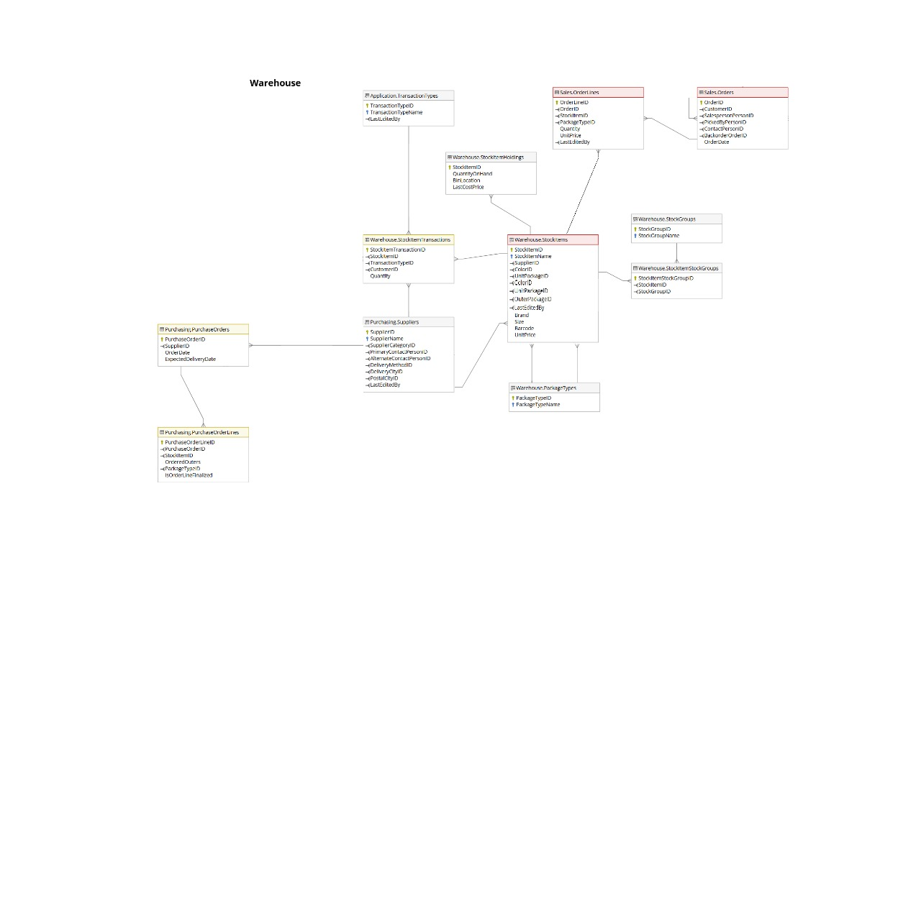

:

### Key Relationships in ERD

* **Customers place orders** → Customer entity links to Selling Orders.
* **Suppliers provide stock** → Supplier entity links to Purchasing Orders.
* **Stock is stored and tracked** → StockItem entity links to **inventory transactions**.
* **Orders contain stock items** → Relationship between **StockItem** and **SellingOrders**.

## **Star Schema (Dimensional Model)**

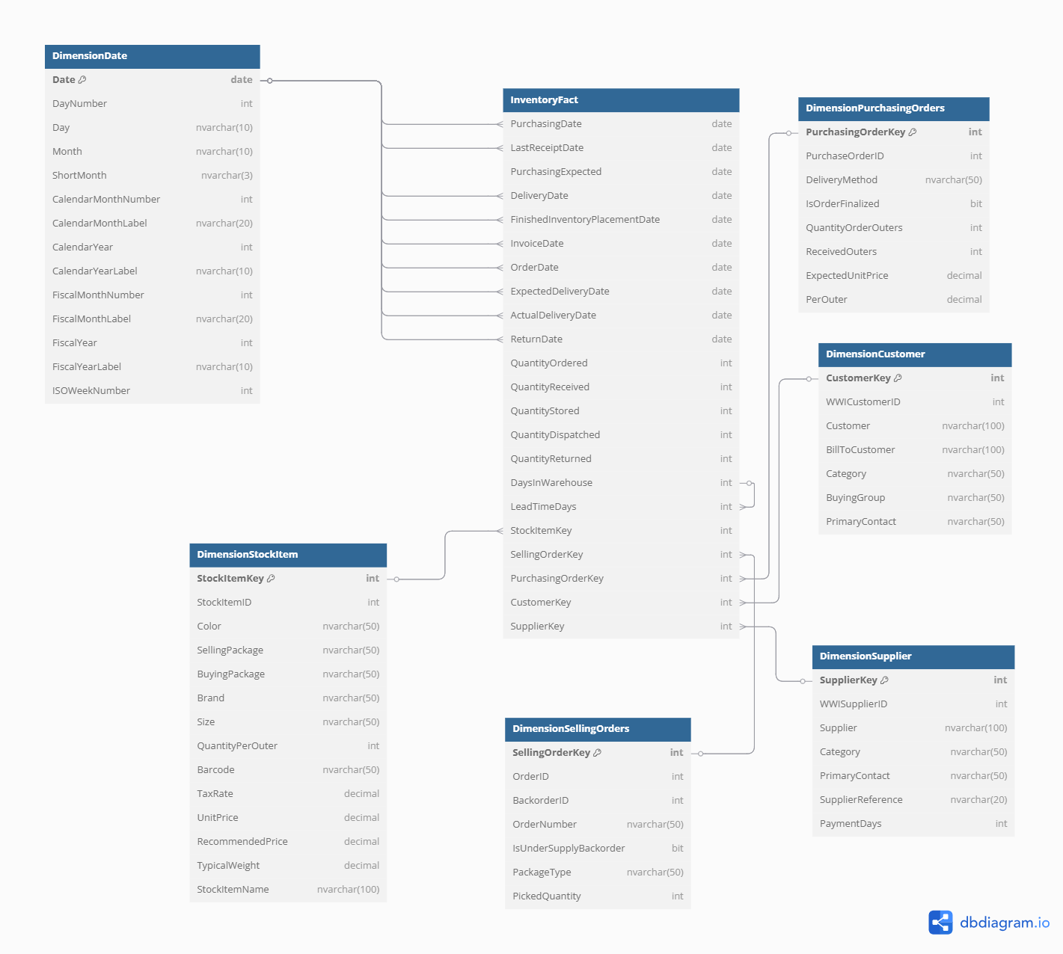

### **1. Fact Table: Inventory Fact(Measures)**

The central table (InventoryFact) records inventory transactions and key performance metrics across different stages of stock movement. Each row represents a specific inventory event, tracking the lifecycle of stock items from **ordering and receiving** to **storage, dispatch, and returns**. This enables precise monitoring of **supplier performance, warehouse efficiency, and stock availability**, helping to optimize restocking and prevent overstocking or understocking.

#### **Fact table :**

* **PurchasingDate → Date when stock was ordered.**
* **LastReceiptDate → Date of the most recent stock receipt.**
* **PurchasingExpected → Supplier's estimated delivery date.**
* **DeliveryDate → When stock actually arrived.**
* **FinishedInventoryPlacementDate → When stock was placed in the warehouse.**
* **InvoiceDate → Date of invoice for stock received.**
* **OrderDate → Date when stock was ordered.**
* **ExpectedDeliveryDate → Supplier's estimated delivery date.**
* **ActualDeliveryDate → When stock actually arrived.**
* **ReturnDate → Date when stock was returned.**
* **QuantityOrdered → Amount of stock requested from suppliers.**
* **QuantityReceived → Amount of stock successfully received.**
* **QuantityStored → Amount of stock stored in the warehouse.**
* **QuantityDispatched → Amount of stock sent to customers.**
* **QuantityReturned → Amount of stock returned.**
* **DaysInWarehouse → Duration stock stayed in storage.**
* **LeadTimeDays → Days between order placement and receipt.**
* **StockItemKey → Identifier for the stock item.**
* **SellingOrderKey → Identifier for the selling order.**
* **PurchasingOrderKey → Identifier for the purchasing order.**
* **CustomerKey → Identifier for the customer.**
* **SupplierKey → Identifier for the supplier.**

### **2. DIMENSION TABLES**

EACH DIMENSION TABLE PROVIDES additional business context to analyze inventory trends.

* **DimensionDate**: Provides time-based context for analyzing inventory trends, tracking stock movements over different time periods.
  + **Date** – The specific date entry.
  + **DayNumber** – Numeric representation of the day in the month.
  + **Day** – Name of the day (e.g., Monday, Tuesday).
  + **Month** – Full name of the month.
  + **ShortMonth** – Abbreviated month name (e.g., Jan, Feb).
  + **CalendarMonthNumber** – Month number in the calendar year (1-12).
  + **CalendarMonthLabel** – Month with the corresponding year (e.g., Jan 2024).
  + **CalendarYear** – The full calendar year.
  + **CalendarYearLabel** – Label format for the year (e.g., "FY2024").
* **DimensionCustomer**: Adds insights into customer demand patterns and purchasing behaviors.
  + **CustomerKey** – Unique identifier for the customer.
  + **WWICustomerID** – Internal company-assigned customer ID.
  + **Customer** – Name of the customer.
  + **BillToCustomer** – The entity responsible for payment.
  + **Category** – Customer classification (e.g., Retail, Wholesale).
  + **BuyingGroup** – Customer group for bulk purchasing advantages.
  + **PrimaryContact** – Name of the main contact person.
* **DimensionSupplier**: Helps analyze supplier reliability, delivery performance, and sourcing trends.
  + **SupplierKey** – Unique identifier for the supplier.
  + **WWISupplierID** – Internal supplier ID.
  + **Supplier** – Name of the supplier company.
  + **Category** – Type of supplier (e.g., Local, International).
  + **PrimaryContact** – Name of the supplier's main representative.
  + **SupplierReference** – Reference code for supplier identification.
  + **PaymentDays** – Number of days allowed for invoice payment.
  + DeliveryMethodID
* **DimensionStockItem**: Provides details on stock characteristics such as brand, size, and packaging.
  + **StockItemKey** – Unique identifier for each stock item.
  + **StockItemID** – Internal ID assigned to stock items.
  + **Color** – Color specification of the stock item.
  + **SellingPackage** – Packaging format for sale (e.g., "Box of 10").
  + **BuyingPackage** – Packaging format for procurement (e.g., "Carton of 50").
  + **Brand** – Brand name of the stock item.
  + **Size** – Size specifications of the stock item.
  + **QuantityPerOuter** – Number of units per outer packaging.
  + **Barcode** – Universal barcode for scanning.
  + **TaxRate** – Tax percentage applied to the item.
  + **UnitPrice** – Price per individual unit.
  + **TypicalWeight** – Approximate weight of the stock item.
  + **StockItemName** – Official product name.
* **DimensionSellingOrders**: Enables tracking of customer orders, fulfillment rates, and backorder occurrences.
  + **SellingOrderKey** – Unique identifier for the sales order.
  + **OrderID** – Internal order number.
  + **OrderNumber** – The actual order number used in transactions.
  + **PackageType** – Type of packaging used for shipping.
  + **PickedQuantity** – Number of items picked for delivery.
  + **DimensionPurchasingOrders**: Helps assess purchasing trends, order volumes, and supplier commitments.
  + **PurchasingOrderKey** – Unique identifier for the purchase order.
  + **PurchaseOrderID** – Internal purchase order reference.
  + **DeliveryMethod** – The transportation mode for delivery (e.g., Air, Truck).
  + **IsOrderFinalized** – Indicates if the order is complete and closed.
  + **QuantityOrderOuters** – Number of outer units ordered.
  + **ReceivedOuters** – Number of outer units received.
  + **ExpectedUnitPrice** – The projected price per unit at order placement.
  + **PerOuter** – The price per outer packaging unit.

## **Grain of the Fact Table**

Each row corresponds to a specific **stock transaction** for a given **stock item**, linked to a particular **purchasing order** and **supplier**. It tracks the movement of inventory through different stages, including the quantity ordered, received, stored, dispatched, and returned. Additionally, it records key dates such as the order date, expected delivery date, actual delivery date, invoice date, and return date. The inclusion of measures like **LeadTimeDays** and **DaysInWarehouse** indicates that the fact table also tracks performance metrics related to stock movement efficiency